**ArcSight Syslog connector Installation.**

**Connector needs to be installed:**

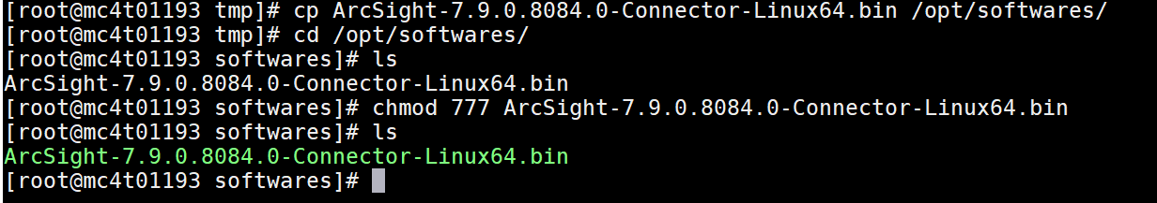

**Create a folder for connector installation:**



**Execute the below command:**



**Enter an absolute path:**

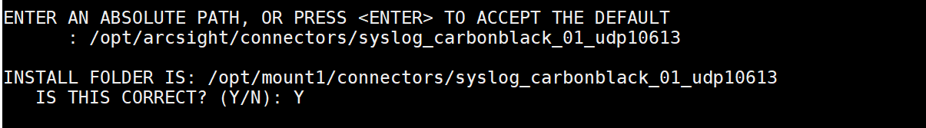

**Chose link location:**

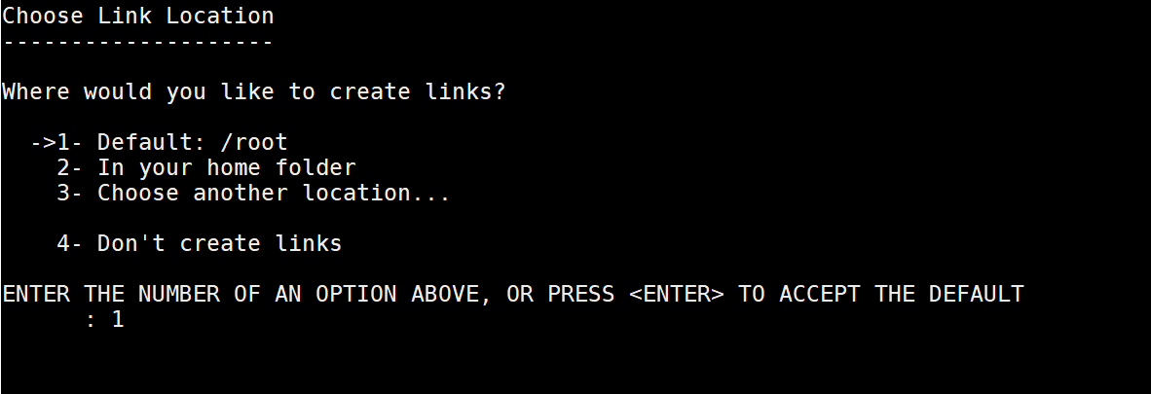

**Installation completion now need to configure connector:**

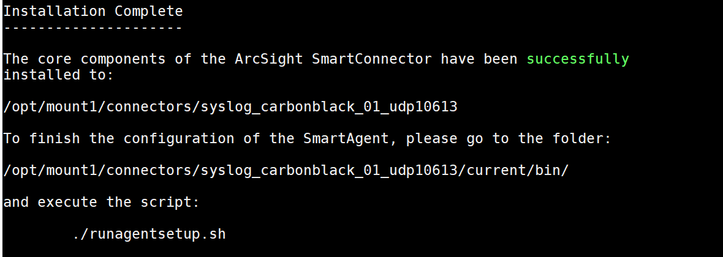

**Run Connector agent:**



**Add a connector:**

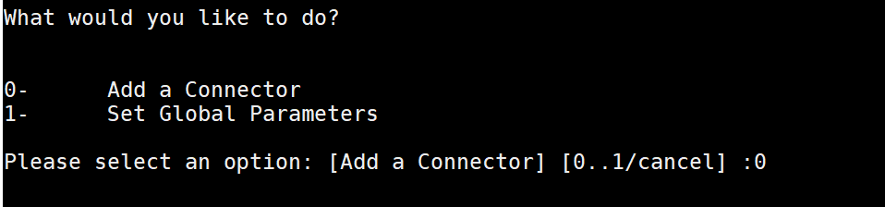

**Select 119-Syslog Deamon.**

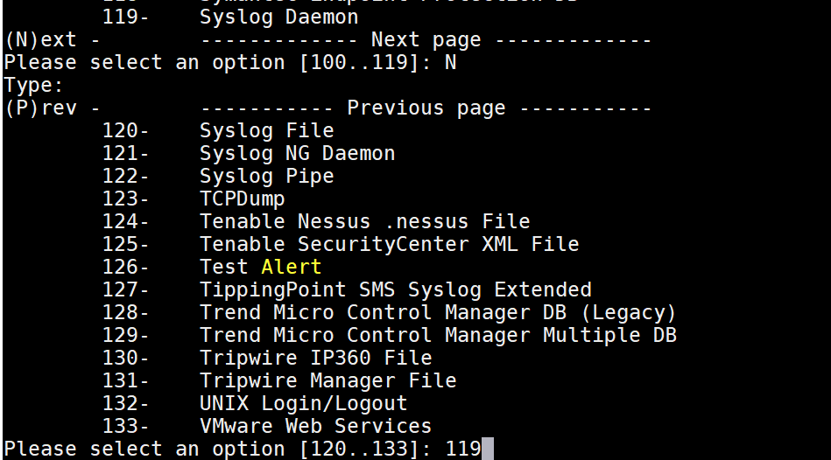

**Verify the values:**

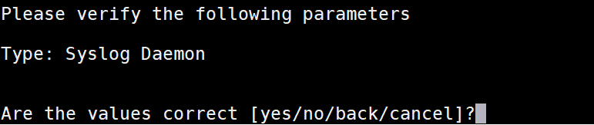

**Change Network port if you need by default it’s 514:**

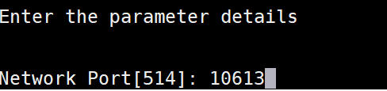

**Verify the parameter:**

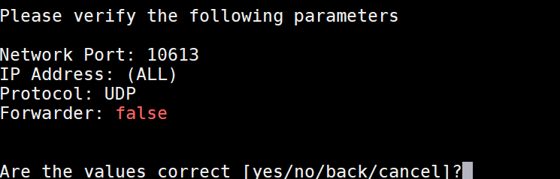

**Select the destination:**

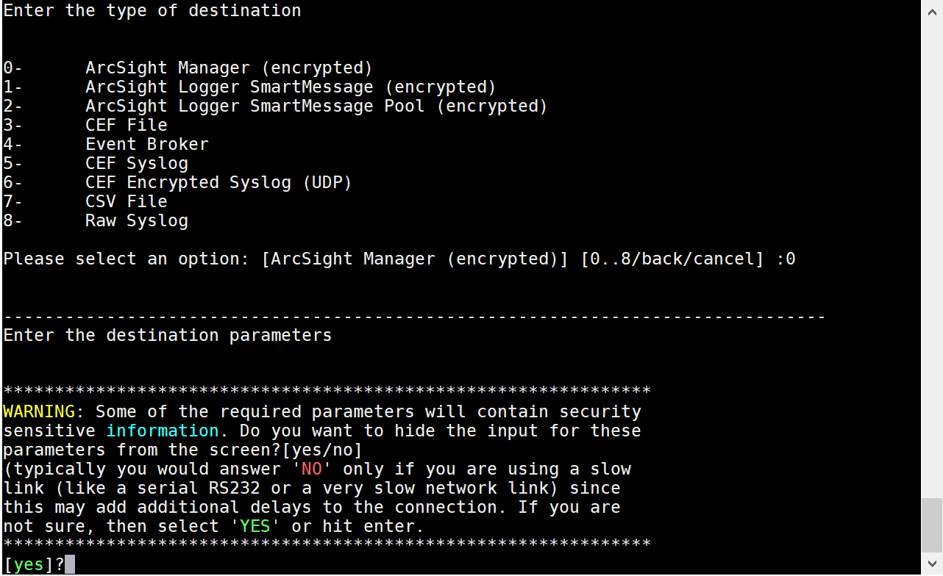

**Enter Manager Details:**

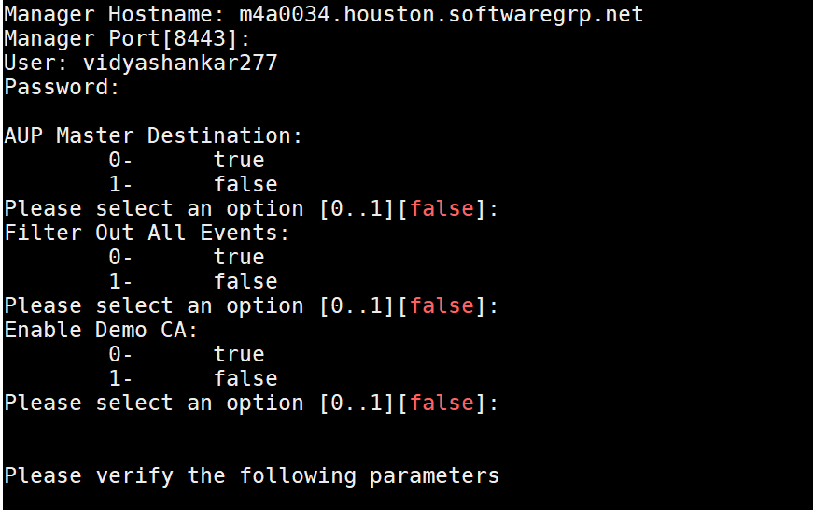

**Enter connector details:**

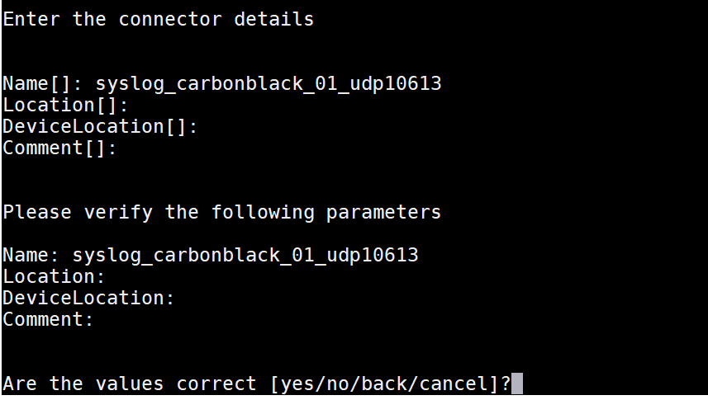

**Import the certificate to connector from destination:**

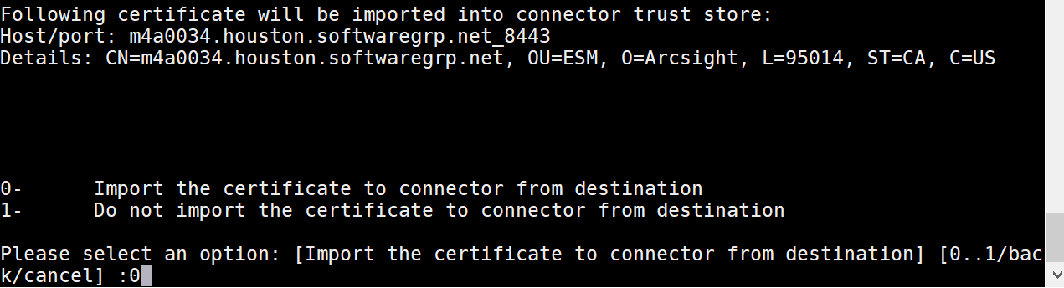

**Install as a service:**

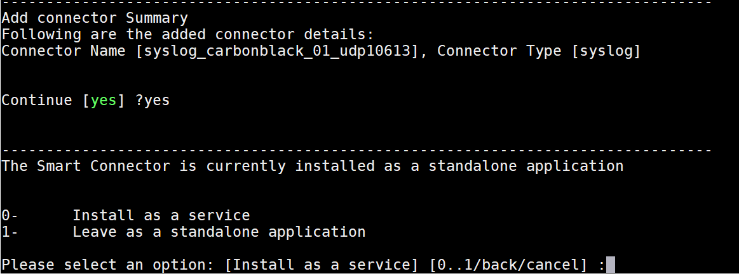

**Enter internal service and display name:**

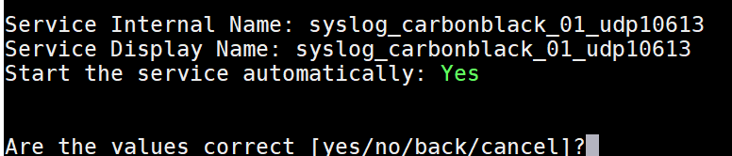

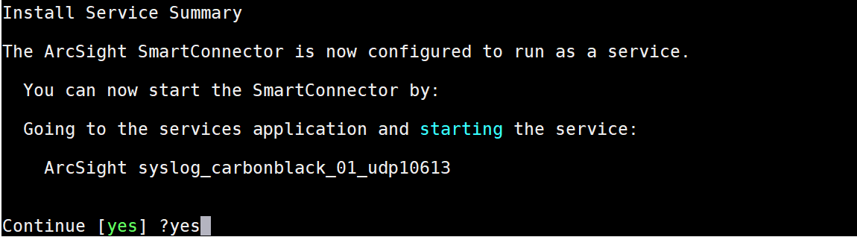

**Start connector services:**



**It should come as successful:**

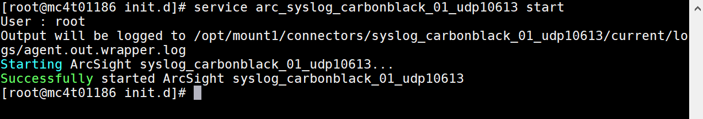

**Connector should be up and running:**

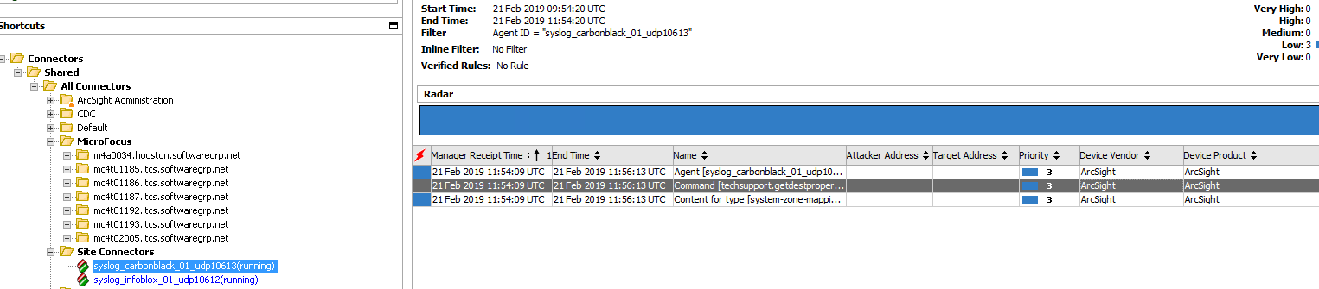

**ArcSight connector installation commands:**

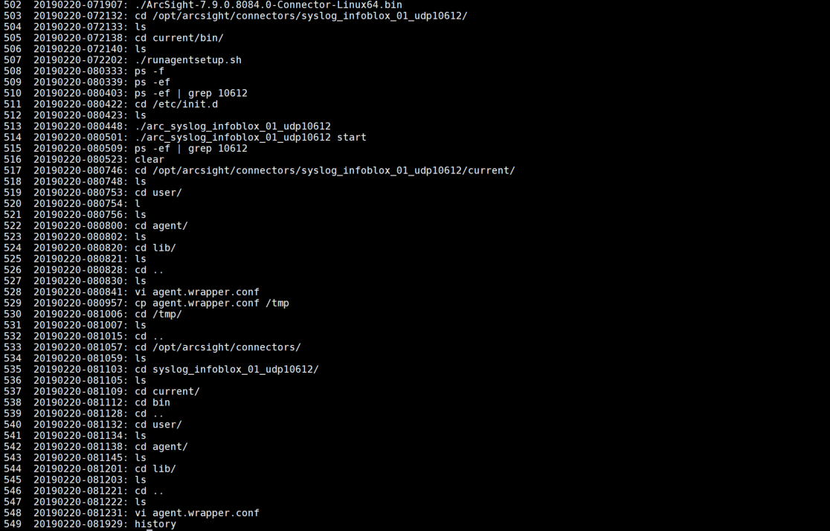

**Change max memory and initial memory.**

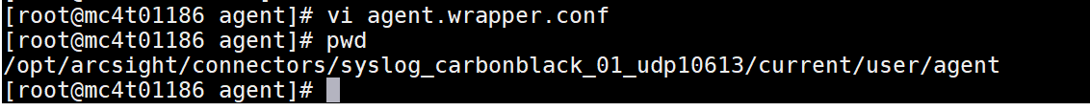

**Changes made in agent.wrapper.conf**

